**B3M5 Grammar**

**Attributive clause**

By Qinmei

**Teaching objectives:**

**At the end of the class, the Ss will be able to**

1. know what is attributive clause, and know what are antecedent, relatives.

2. analyze the structure of an attributive clause

3. know how to use the attributive clause to help to introduce a person.

***Ⅰ. Lead-in***

Task : lead Ss to review what they have learned about the great ancient people in China.

***Ⅱ. Presentation***

**Task 1: read the passage and answer the following questions.**

Here we have an essay about the Chinese philosophers who have most influenced Chinese civilization. / The thinker whose influence has been the greatest was Confucius. He was born in 551 B.C. in the State of Lu and died in 497 B.C. This was a period which was called the Golden Age of Chinese thought. Confucius travelled from state to state explaining his beliefs and he also taught the respect of elders by their children. He believed in a strong family where order and duty were important qualities. He thought a good ruler must be kind and honest and the state must impose order and justice on its citizen. Confucius’s influence is so great that it spreads to Japan, Korea and Vietnam. And it’s still important in Chinese society today. But he was not the only important philosopher who has had a lasting influence. There was also Mencius, Laozi, Zhuangzi and so on.

**Qs:**

1. What is the essay mainly about?

2. Why does the author choose to talk about Confucius among all the thinkers?

3. In which period was Confucius born?

4. What did Confucius believe in?

**Task 2: observe and analyze the structure of the attributive clause.**

**Eg: An essay about the Chinese philosophers who have most influenced Chinese civilization**

***Ⅲ.******Practice***

**Task1 (pair-work): First: write two simple sentences according to the pictures and key words.**

**Second: Combine the simple sentences into the attributive clause.**

**Activity1:**

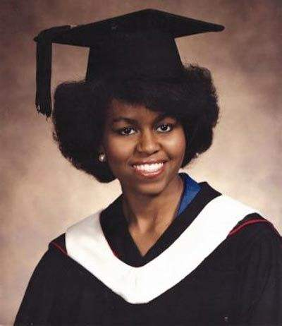 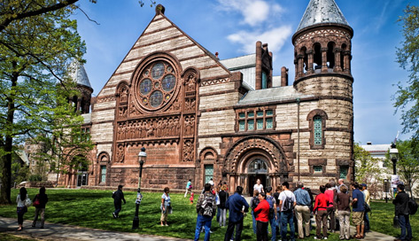

 good ones?

Where did she graduate from?

Sentence 1________________________________________________

Sentence 2________________________________________________

________________________________________________________________(attibutive clause)

**Activity 2:**

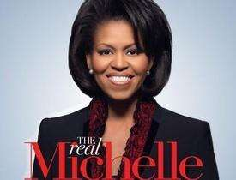 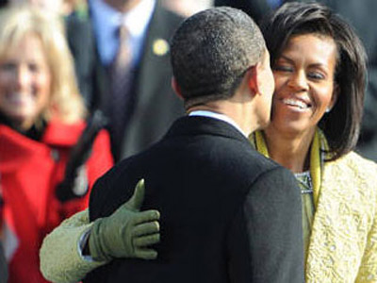

**Law firm Where did she meet Barack Obama?**

**Where did she once work?**

Sentence 1________________________________________________

Sentence 2________________________________________________

________________________________________________________________(attibutive clause)

**Activity 3:**

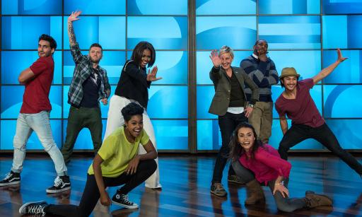 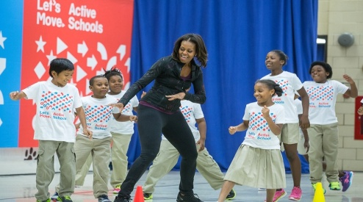

**A program , Let’s Move! Children, active, healthy**

Sentence 1________________________________________________

Sentence 2________________________________________________

________________________________________________________________(attibutive clause)

**Task 2: Writing (group work)**

**An introduction about a famous person**

**Requirements:**

1. Write at least 3-4 sentences

2. Use attributive clauses where necessary (which/that/who/whose/where…)

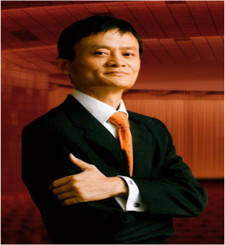

**Name: Ma Yun**

**Birth place: Hangzhou, China**

**Job: Alibaba Group Chairman**

**University: Hangzhou Normal University (Major: English)**

**Motto: never give up**

**Ma Yun** ____________________________________________________. (businessman, born)

He___________________________________________________________. (Alibaba, famous internet company)

When he was young, he ___________________________________________________________. (Hangzhou Normal University, where, English).

He has China’s 2nd highest_________________________________________________________.

(Net worth, $22 Billion)

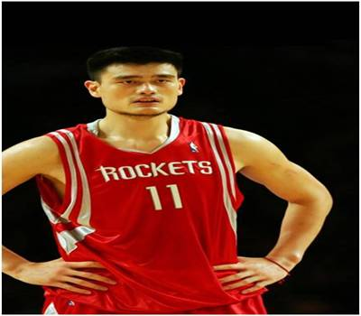

**Name: Yao Ming**

**Birth place: Shanghai, China**

**Job: Professional Basketball Player**

**First professional team: Shanghai Sharks**

**Nickname: “The Little Giant”**

**Yao Ming** is a______________________________________________________.(professional basketball player, born, Shanghai).

He started playing_________________________________________________________. (Sharks, basketball team, Shanghai).

In America he joined______________________________________________________.(Rockets, team, Houston, Texas) .

There, he had___________________________________________________________.(nickname, “The Little Giant”)

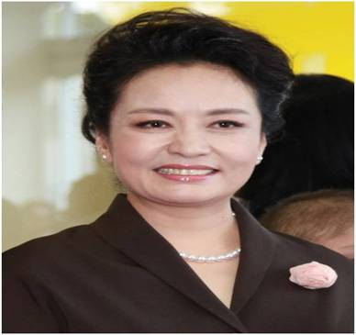

**Name: Peng Liyuan**

**Date of birth: November 20, 1962 (Year of the Tiger)**

**Former job: Folk Music Singer**

**Current state: First Lady of China**

**First National Singing Appearance: CCTV New Year’s Gala, 1982**

**Peng Liyuan** is a former_________________________________________.(singer, who, Chinese Folk Music).

She was born_________________________________________________________.(1962, Year of the Tiger)

She is________________________________________________. (married, Xi Jinping, President of China)

She_______________________________________________.(famous, first TV appearance, 1982 CCTV New Year’s Gala)

***IV. Conclusion***